WEEK 1
MODULE 2 : Data Structures and Algorithms

NAME : ANANTH KARTHIK V
SUPERSET ID : 6738185

Exercise 1: Inventory Management System
Given Scenario:
You are developing an inventory management system for a warehouse. Efficient data storage and retrieval are crucial
Solution:
Thousands of products are handled in warehouses, where effective search, update, and deletion are essential. Slow performance and bottlenecks can result from poor data structures, particularly as the inventory grows.
Suitable Data Structures:
- Array List: Good for sequential storage but search and update are slow.
Time Complexity: O(n)
- HashMap: Used for fast access by key, ideal for lookups, updates, and deletions.
Time Complexity: O(n)
- TreeMap: Maintains sorted order by key. Useful when sorted traversal or range-based search is required.
- Time Complexity: O (log n)

Code:
InventoryManagementSystem.java:
import java.util.HashMap;
import java.util.Map;
class Item {
int itemCode;
String itemName;
int stockCount;
double unitCost;
public Item(int itemCode, String itemName, int stockCount, double unitCost) {
this.itemCode = itemCode;
this.itemName = itemName;
this.stockCount = stockCount;
this.unitCost = unitCost;
}
public void printItemDetails() {
System.out.println("Item Code: " + itemCode);
System.out.println("Item Name: " + itemName);
System.out.println("Stock Count: " + stockCount);
System.out.println("Unit Cost: ₹" + unitCost);
System.out.println();
}
}
class StockManager {
private Map<Integer, Item> itemRecords = new HashMap<>();
public void insertItem(Item item) {
itemRecords.put(item.itemCode, item);
System.out.println("Item successfully inserted.");
}
public void modifyItem(int code, String name, int stock, double cost) {
if (itemRecords.containsKey(code)) {
Item i = itemRecords.get(code);
i.itemName = name;
i.stockCount = stock;
i.unitCost = cost;
System.out.println("Item updated successfully.");
} else {
System.out.println("Item with given code not found.");
}
}
public void removeItem(int code) {
if (itemRecords.remove(code) != null) {
System.out.println("Item removed from stock.");
} else {
System.out.println("Item not found in records.");
}
}
public void showAllItems() {
for (Item i : itemRecords.values()) {
i.printItemDetails();
}
}
}
class InventoryManagementSystem {
public static void main(String[] args) {
StockManager manager = new StockManager();

manager.insertItem(new Item(101, "Smartphone", 25, 19999.99));
manager.insertItem(new Item(102, "Wireless Charger", 100, 1499.50));

manager.showAllItems();

manager.modifyItem(101, "5G Smartphone", 20, 24999.75);
manager.removeItem(102);

manager.showAllItems();
}
}

Output:
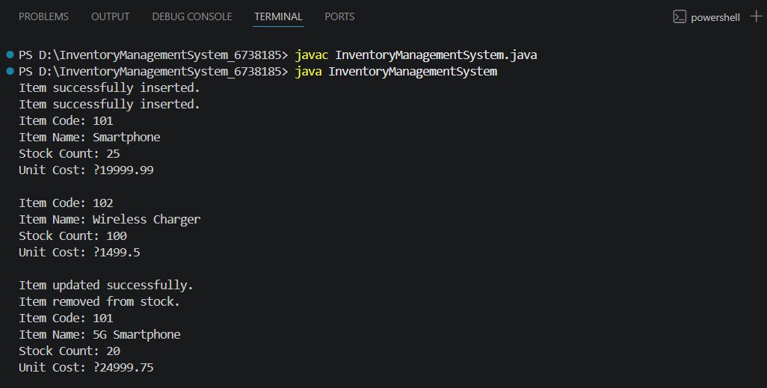

Time Complexity Analysis:

Add Product – O(1) Insert into HashMap by key.
Update Product – O(1) Direct access and update using key.
Delete Product – O(1) Remove by key from HashMap.
Display All – O(n) Iterates through all product values

Exercise 2: E-commerce Platform Search Function
Given Scenario:
You are working on the search functionality of an e-commerce platform. The search needs to be optimized for fast performance.
Solution:
Big O Notation:
Mathematical representation of an algorithm's complexity or performance, particularly how its memory or runtime grows with increasing input size.
Search operations:
There are two types of searching methods:
i) Linear Search
ii) Binary Search
Linear Search:
Best Case: O(1)
Average Case: O(n)
Worst Case: O(n)
Binary Search:
Best Case : O(1)
Average Case : O(log n)
Worst Case : O(log n
Code:
EcommerceSearch.java:
import java.util.Arrays;
import java.util.Comparator;
public class EcommerceSearch {
static class Item {
int itemId;
String itemTitle;
String itemGroup;
public Item(int itemId, String itemTitle, String itemGroup) {
this.itemId = itemId;
this.itemTitle = itemTitle;
this.itemGroup = itemGroup;
}
public String showDetails() {
return "ID : " + itemId + " Title : " + itemTitle + " Group : " + itemGroup;
}
}
public static Item linearLookup(Item[] items, String keyword) {
for (Item i : items) {
if (i.itemTitle.equalsIgnoreCase(keyword)) {
return i;
}
}
return null;
}
public static Item binaryLookup(Item[] items, String keyword) {
int start = 0;
int end = items.length - 1;
while (start <= end) {
int mid = (start + end) / 2;
int compare = items[mid].itemTitle.compareToIgnoreCase(keyword);
if (compare == 0) {
return items[mid];
} else if (compare < 0) {
start = mid + 1;
} else {
end = mid - 1;
}
}
return null;
}
public static void arrangeItems(Item[] items) {
Arrays.sort(items, Comparator.comparing(i -> i.itemTitle.toLowerCase()));
}
public static void main(String[] args) {
Item[] itemArray = {
new Item(101, "Tablet", "Gadgets"),
new Item(102, "Notebook", "Computing"),
new Item(103, "Sunglasses", "Wearables"),
new Item(104, "Jacket", "Apparel")
};
String searchKeyword = "Jacket";
Item result1 = linearLookup(itemArray, searchKeyword);
System.out.println("Linear Search : " + (result1 != null ? result1.showDetails() : "Item Not Found"));
arrangeItems(itemArray);
Item result2 = binaryLookup(itemArray, searchKeyword);
System.out.println("Binary Search : " + (result2 != null ? result2.showDetails() : "Item Not Found"));
}
}

Output:
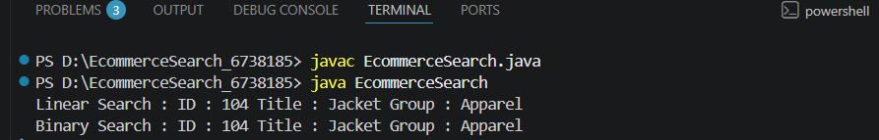

Linear Search:
Time Complexity – O(n)
Space Complexity – O(1)
Binary Search:
Time Complexity – O(log n)
Space Complexity – O(1)

Linear Search is simple and works on unsorted data. Whereas Binary Search is more efficient for large datasets but requires sorted data.
For e-commerce platforms with large datasets, Binary Search is preferred for fast performance. Binary Search is a good algorithm for the searching approach in e-commerce platforms.

Exercise 3: Sorting Customer Orders
Given Scenario:
You are tasked with sorting customer orders by their total price on an e-commerce platform. This helps in prioritizing high-value orders.
Solution:
Sorting Algorithms:
- Bubble Sort:
Repeatedly compares adjacent elements and swaps them if they are out of order.
- Insertion Sort:
Builds the sorted array by inserting each element into its correct position in the sorted part.
- Quick Sort:
A divide-and-conquer algorithm that picks a pivot, partitions the array, and recursively sorts the subarrays.
- Merge Sort:
Divides the array into halves, sorts them recursively, and merges the sorted halves.
Code:
Sorting.java:
class Sorting {
static class Invoice {
String invoiceId;
String clientName;
double amountDue;

public Invoice(String invoiceId, String clientName, double amountDue) {
this.invoiceId = invoiceId;
this.clientName = clientName;
this.amountDue = amountDue;
}

public void show() {
System.out.println(invoiceId + " " + clientName + " ₹" + amountDue);
}
}

public static void bubbleArrange(Invoice[] records) {
int len = records.length;
for (int i = 0; i < len - 1; i++) {
for (int j = 0; j < len - 1 - i; j++) {
if (records[j].amountDue > records[j + 1].amountDue) {
Invoice temp = records[j];
records[j] = records[j + 1];
records[j + 1] = temp;
}
}
}
}

public static void quickArrange(Invoice[] records, int start, int end) {
if (start < end) {
int pivot = separate(records, start, end);
quickArrange(records, start, pivot - 1);
quickArrange(records, pivot + 1, end);
}
}

private static int separate(Invoice[] records, int start, int end) {
double pivotValue = records[end].amountDue;
int index = start - 1;
for (int k = start; k < end; k++) {
if (records[k].amountDue <= pivotValue) {
index++;
Invoice temp = records[index];
records[index] = records[k];
records[k] = temp;
}
}
Invoice temp = records[index + 1];
records[index + 1] = records[end];
records[end] = temp;
return index + 1;
}

public static void showAllInvoices(Invoice[] records) {
for (Invoice inv : records) {
inv.show();
}
}

public static void main(String[] args) {
Invoice[] invoices = {
new Invoice("INV101", "Anya", 875.0),
new Invoice("INV102", "Bharat", 1200.5),
new Invoice("INV103", "Chitra", 560.75),
new Invoice("INV104", "Dev", 2300.0),
new Invoice("INV105", "Esha", 999.99)
};

System.out.println("Original Invoice List:");
showAllInvoices(invoices);

bubbleArrange(invoices);
System.out.println("After Bubble Sort (by amountDue):");
showAllInvoices(invoices);
invoices = new Invoice[] {
new Invoice("INV101", "Anya", 875.0),
new Invoice("INV102", "Bharat", 1200.5),
new Invoice("INV103", "Chitra", 560.75),
new Invoice("INV104", "Dev", 2300.0),
new Invoice("INV105", "Esha", 999.99)
};
quickArrange(invoices, 0, invoices.length - 1);
System.out.println("After Quick Sort (by amountDue):");
showAllInvoices(invoices);
}
}
Output:
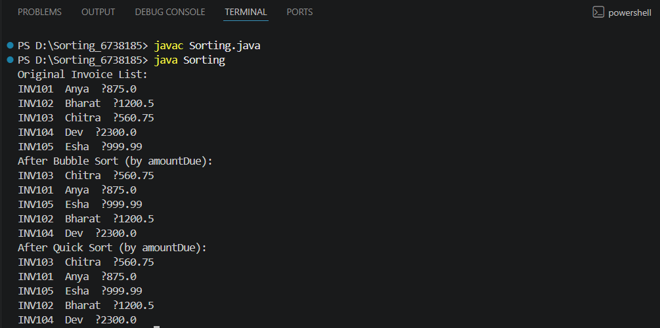

Time Complexity and Performance:
Bubble Sort:
Time Complexity:
i)Best Case – O(n)
ii)Average Case – O(n^2)
iii)Worst Case – O(n^2)
Space Complexity – O(1)
Quick Sort:
Time Complexity:
i)Best Case – O(n log n)
ii)Average Case – O(n log n)
iii)Worst Case – O(n^2)
Space Complexity – O(log n)
Bubble Sort is simple but inefficient for large datasets due to its O(n²) complexity. Quick Sort is faster and more scalable because it uses a divide-and-conquer strategy. For performance-critical applications like order sorting, Quick Sort is preferred. Choosing the right sorting algorithm improves system efficiency and responsiveness.

Exercise 4: Employee Management System
Given Scenario:
You are developing an employee management system for a company. Efficiently managing employee records is crucial.
Solution:
Arrays are contiguous blocks of memory where elements are stored sequentially. Accessing an element by index is efficient and takes O(1) time using the formula:
base_address + index * element_size
Advantages of Array:
- Constant-time random access using indices (O(1))
- Straightforward to implement for fixed-size data
- Improved cache locality for better performance
Code:
EmployeeManagementSystem.java:
class EmployeeManagementSystem {
static class Staff {
int staffId;
String fullName;
String designation;
double monthlyPay;
public Staff(int staffId, String fullName, String designation, double monthlyPay) {
this.staffId = staffId;
this.fullName = fullName;
this.designation = designation;
this.monthlyPay = monthlyPay;
}public void printDetails() {
System.out.println(staffId + " " + fullName + " " + designation + " ₹" + monthlyPay);
}
}static final int MAX_STAFF = 100;
static Staff[] staffRecords = new Staff[MAX_STAFF];
static int currentCount = 0;

public static void registerStaff(Staff member) {
if (currentCount < MAX_STAFF) {
staffRecords[currentCount++] = member;
System.out.println("Staff member added: " + member.fullName);
} else {
System.out.println("Cannot add more staff. Maximum capacity reached.");
}
}
public static void findStaffById(int id) {
for (int i = 0; i < currentCount; i++) {
if (staffRecords[i].staffId == id) {
System.out.println("Staff found:");
staffRecords[i].printDetails();
return;
}
}
System.out.println("Staff with ID " + id + " not found.");
}
public static void showAllStaff() {
if (currentCount == 0) {
System.out.println("No staff records available.");
return;
}
System.out.println("Staff Directory:");
for (int i = 0; i < currentCount; i++) {
staffRecords[i].printDetails();
}
}
public static void removeStaff(int id) {
for (int i = 0; i < currentCount; i++) {
if (staffRecords[i].staffId == id) {
for (int j = i; j < currentCount - 1; j++) {
staffRecords[j] = staffRecords[j + 1];
}
staffRecords[--currentCount] = null;
System.out.println("Staff with ID " + id + " has been deleted.");
return;
}
}
System.out.println("Staff with ID " + id + " not found.");
}
public static void main(String[] args) {
registerStaff(new Staff(301, "Nina Verma", "Team Lead", 92000));
registerStaff(new Staff(302, "Ravi Kumar", "Software Engineer", 68000));
registerStaff(new Staff(303, "Leena Shah", "UI/UX Specialist", 61000));

System.out.println();
showAllStaff();

System.out.println("Looking for staff with ID 302:");
findStaffById(302);

System.out.println();
System.out.println("Deleting staff with ID 301:");
removeStaff(301);

System.out.println("Staff list after deletion:");
showAllStaff();
}
}
Output:
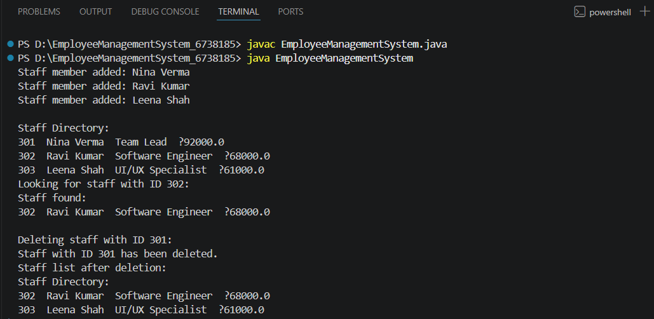

Time Complexity of Operations:
Add-O(1)
Search- O(n)
Traverse- O(n)
Delete- O(n)
Limitations of Arrays:
Fixed size: Cannot grow or shrink dynamically
Inefficient deletion/insertion: Requires shifting elements
Memory waste: Pre-allocated space may be unused
When to Use Arrays:
When the number of elements is fixed and known in advance
When fast index-based access is required
When memory consumption is predictable

Exercise 5: Task Management System
Scenario:
You are developing a task management system where tasks need to be added, deleted, and traversed efficiently.
Solution:
Singly Linked List:
Each node stores data and a pointer to the next node.
Allows traversal in a single direction only.
Insertion and deletion at the head are efficient.
Ideal when memory usage is a priority over bidirectional navigation.
Doubly Linked List:
Each node holds data, a pointer to the next node, and a pointer to the previous
node.
Enables forward and backward traversal.
More flexible but uses additional memory for the extra pointer.
Code:
TaskManagementSystem.java:
class TaskManagementSystem {

static class Task {
int taskId;
String taskName;
String status;
Task next;
public Task(int taskId, String taskName, String status) {
this.taskId = taskId;
this.taskName = taskName;
this.status = status;
this.next = null;
}
public void showDetails() {
System.out.println(taskId + " " + taskName + " " + status);
}
}
static class TaskList {
Task head = null;
public void insertTask(int taskId, String taskName, String status) {
Task newTask = new Task(taskId, taskName, status);
if (head == null) {
head = newTask;
} else {
Task current = head;
while (current.next != null) {
current = current.next;
}
current.next = newTask;
}
System.out.println("New task inserted: " + taskName);
}
public void findTask(int taskId) {
Task current = head;
while (current != null) {
if (current.taskId == taskId) {
System.out.println("Task found:");
current.showDetails();
return;
}
current = current.next;
}
System.out.println("No task found with ID: " + taskId);
}

public void listAllTasks() {
if (head == null) {
System.out.println("Task list is empty.");
return;
}
System.out.println("All Tasks:");
Task current = head;
while (current != null) {
current.showDetails();
current = current.next;
}
}
public void removeTask(int taskId) {
if (head == null) {
System.out.println("No tasks to delete.");
return;
}
if (head.taskId == taskId) {
head = head.next;
System.out.println("Deleted task with ID: " + taskId);
return;
}
Task previous = null;
Task current = head;
while (current != null && current.taskId != taskId) {
previous = current;
current = current.next;
}
if (current == null) {
System.out.println("No task found with ID: " + taskId);
} else {
previous.next = current.next;
System.out.println("Deleted task with ID: " + taskId);
}
}
}
public static void main(String[] args) {
TaskList taskManager = new TaskList();
taskManager.insertTask(1, "UI Design", "Pending");
taskManager.insertTask(2, "API Integration", "In Progress");
taskManager.insertTask(3, "Database Setup", "Not Started");
System.out.println();
taskManager.listAllTasks();
System.out.println();
System.out.println("Looking up Task with ID 2:");
taskManager.findTask(2);
System.out.println();
System.out.println("Removing Task with ID 1:");
taskManager.removeTask(1);

System.out.println();
System.out.println("Updated Task List:");
taskManager.listAllTasks();
}
}

Output:
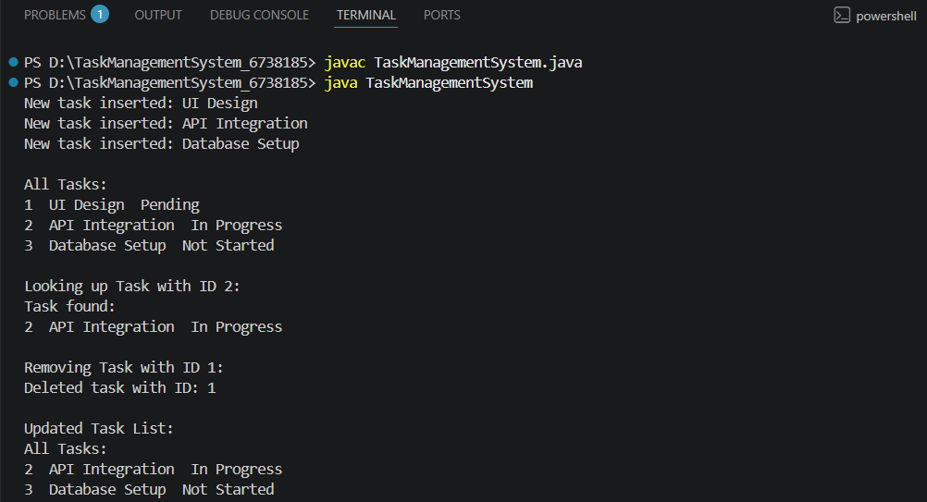
Exercise 6: Library Management System
Scenario:
You are developing a library management system where users can search for books by title or author.
Solution:
Linear Search:
Scans each element one by one until the target is found or the end of the list is reached.
Binary Search:
Works on sorted data. Repeatedly divides the list into halves to find the target more efficiently.
Code:
LibraryManagementSystem.java:
import java.util.Arrays;
import java.util.Comparator;

class LibraryManagementSystem {
static class Volume {
int volumeId;
String volumeTitle;
String writer;

public Volume(int volumeId, String volumeTitle, String writer) {
this.volumeId = volumeId;
this.volumeTitle = volumeTitle;
this.writer = writer;
}

public void printDetails() {
System.out.println(volumeId + " " + volumeTitle + " " + writer);
}
}
static Volume[] library;
public static void searchByTitleLinear(String searchTitle) {
boolean matchFound = false;
for (Volume v : library) {
if (v.volumeTitle.equalsIgnoreCase(searchTitle)) {
System.out.println("Volume found using Linear Search:");
v.printDetails();
matchFound = true;
break;
}
}
if (!matchFound) {
System.out.println("Volume not found using Linear Search.");
}
}
public static void searchByTitleBinary(String searchTitle) {
int left = 0;
int right = library.length - 1;

while (left <= right) {
int middle = (left + right) / 2;
int comparison = searchTitle.compareToIgnoreCase(library[middle].volumeTitle);

if (comparison == 0) {
System.out.println("Volume found using Binary Search:");
library[middle].printDetails();
return;
} else if (comparison < 0) {
right = middle - 1;
} else {
left = middle + 1;
}
}
System.out.println("Volume not found using Binary Search.");
}
public static void sortVolumesByTitle() {
Arrays.sort(library, Comparator.comparing(v -> v.volumeTitle.toLowerCase()));
}
public static void main(String[] args) {
library = new Volume[] {
new Volume(201, "Intro to Java", "Nina Patel"),
new Volume(202, "Data Structures", "Raj Mehra"),
new Volume(203, "Operating Systems", "Kiran Shah"),
new Volume(204, "Network Security", "Zoya Khan")
};
System.out.println("Linear Search:");
searchByTitleLinear("Data Structures");
System.out.println();
System.out.println("Binary Search:");
sortVolumesByTitle();
searchByTitleBinary("Network Security");
}
}

Output:
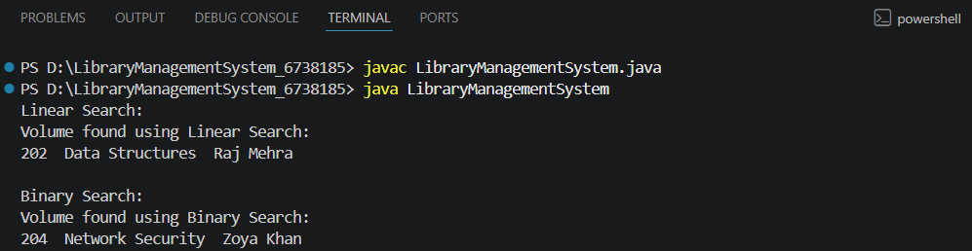
Time Complexity:
i)Linear Search:
Best Case : O(1)
Average Case : O(n)
Worst Case : O(n)
ii)Binary Search:
Best Case : O(1)
Average Case : O(log n)
Worst Case : O(log n)
Use Linear Search:
When the list is unsorted or small.
When insertion/deletion happens frequently and sorting is costly.
Use Binary Search:
When the list is already sorted.
When you have a large static dataset.

Exercise 7: Financial Forecasting
Scenario:
You are developing a financial forecasting tool that predicts future values based on past data.
Recursion:
Recursion is a programming method where a function calls itself to solve smaller subproblems. It is especially effective for problems with repetitive or self-similar structure, such as computing factorials, Fibonacci numbers, or forecasting compound interest over time.
Code:
FinancialForecasting.java:
class FinancialForecasting {
public static double computeProjectedAmount(double baseAmount, double interestRate, int durationYears) {
if (durationYears == 0) {
return baseAmount;
}
return computeProjectedAmount(baseAmount, interestRate, durationYears - 1) * (1 + interestRate);
}
public static void main(String[] args) {
double initialInvestment = 15000;
double yearlyReturnRate = 0.065;
int timeHorizon = 6;
double estimatedOutcome = computeProjectedAmount(initialInvestment, yearlyReturnRate, timeHorizon);
System.out.printf("Estimated Future Value after %d years: %.2f", timeHorizon, estimatedOutcome);
}
}
Output:
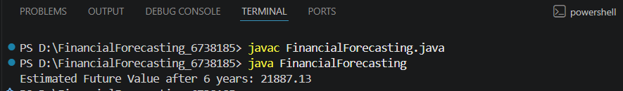
Complexity:
Time Complexity – O(n)
Space Complexity – O(n)
Why is Optimization Needed?
Although the recursion works here deeper or repeated recursion without caching may lead to
Redundant calculations.
Stack overflow for large n.
Optimization Technique:
Use memorization which store already computed values to avoid repeated calls.
For even better performance with low overhead, consider using iteration instead of recursion.

